**CN LAB 4 REPORT**

**Experiment Overview:**

In this experiment, you will configure IP addressing using Variable Length Subnet

Masking (VLSM) for a network. You will create subnets of different sizes to optimize IP

address utilization, and configure routers and PCs to use these subnets. This will

demonstrate efficient IP address allocation using VLSM.

Steps taken to set up the network:-

**STEP 1:**  
 Set up the network by dragging required end devices (PC0 and PC1), and network devices (Router PT, 2 Switch 2960-24TT's) and connect them using straight through copper cables.

**STEP 2:**

Using the config table given, just label the devices with a text box with ip address and subnet mask to ease it up

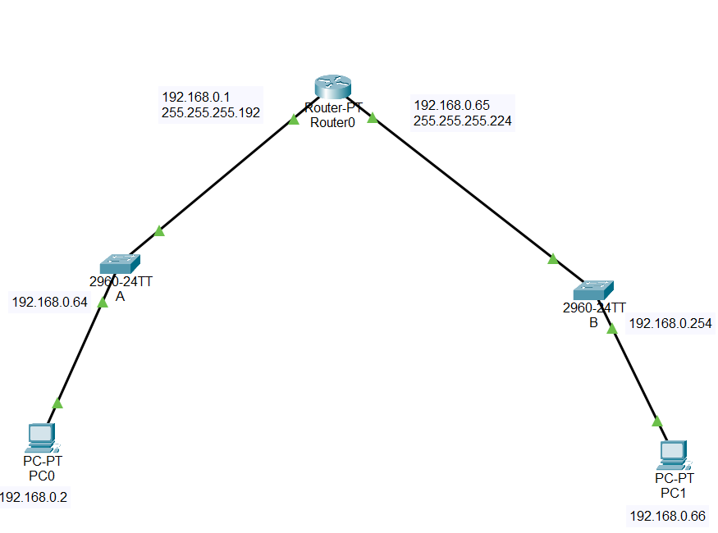

**STEP 3:**

Tap on Router-PT and navigate to the physical tab, add PT-ROUTER-NM-1CGE Module to the router after turning the power off, and turn on the power after adding at least two of those modules.

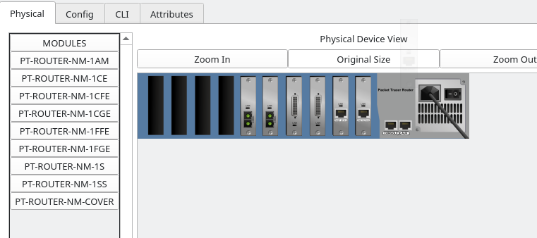

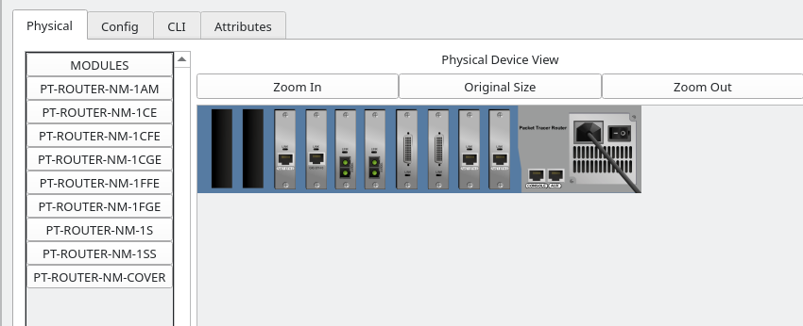

**STEP 4:**

Now connect the Switches via Straight through the cable to the router PT on GigabitEthernet 6/0 and 7/0 respectively.

**STEP 5:**

Open the Router PT and open the CLI tab;

On CLI tab follow up with these commands below;

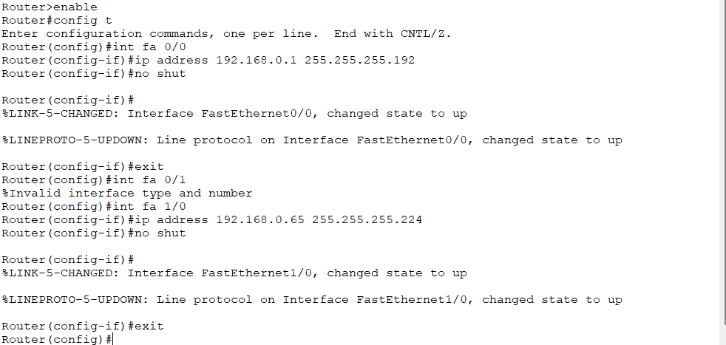

**STEP 6:**

Open switches and open the CLI and use the commands as shown

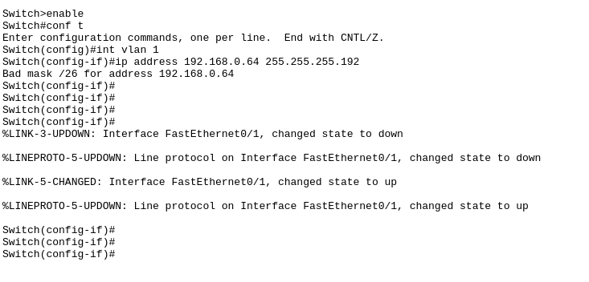

**STEP 7:** Open the PC0 and PC1 and configure IP addresses

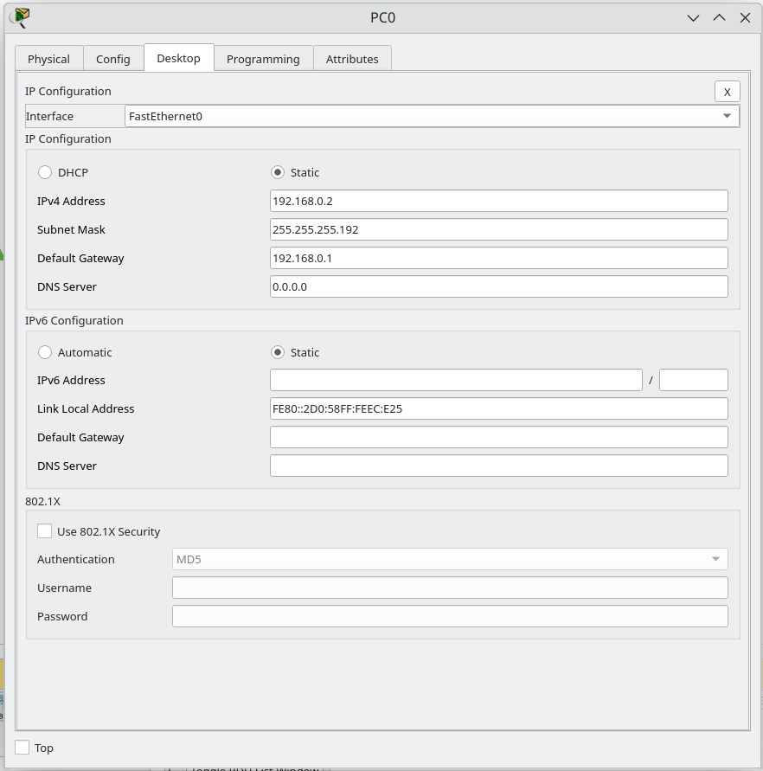

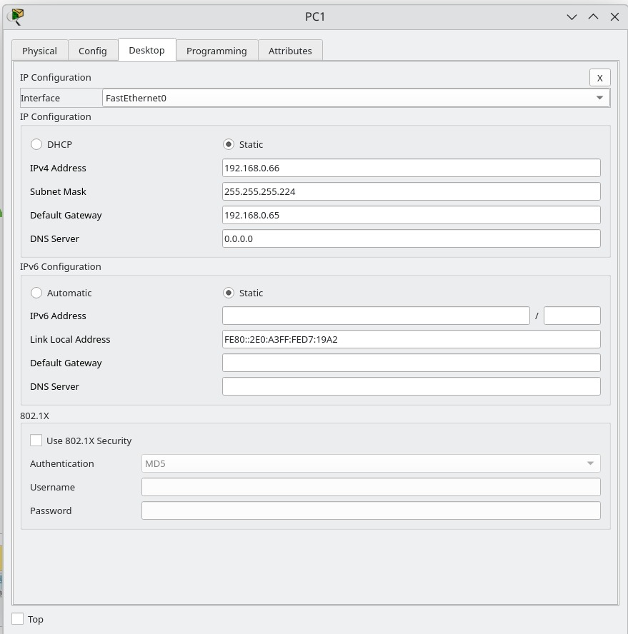

**STEP 8:**

Ping PC1 from PC0

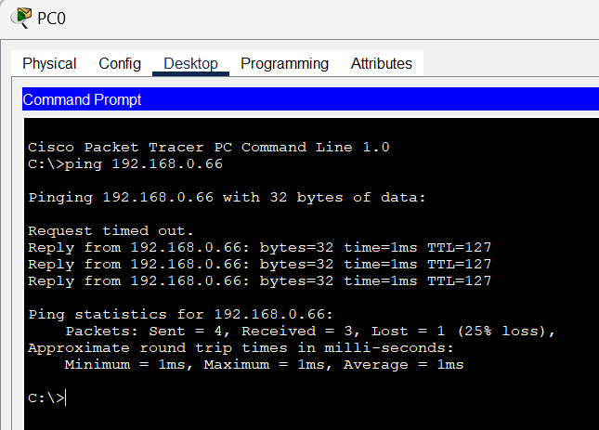

Simulation ping PC1 from PC0:

ARP REQUEST:

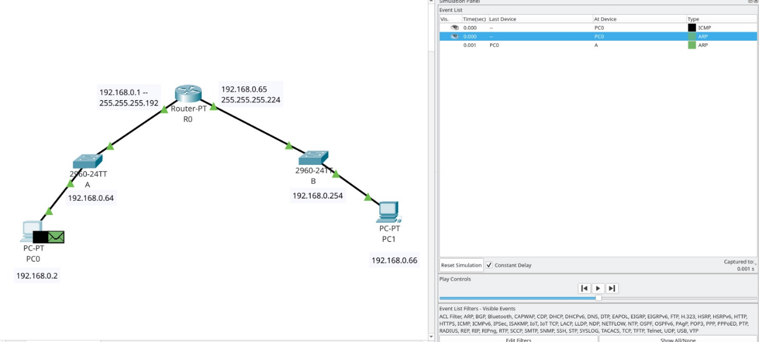

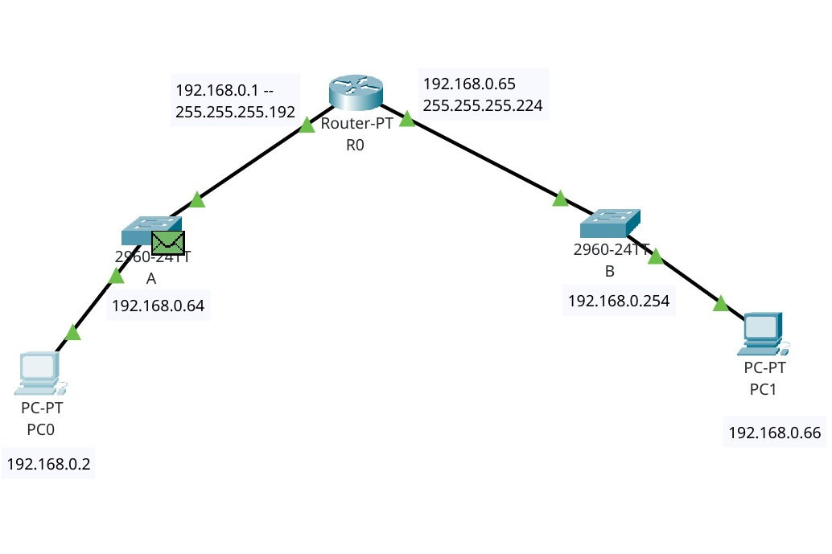

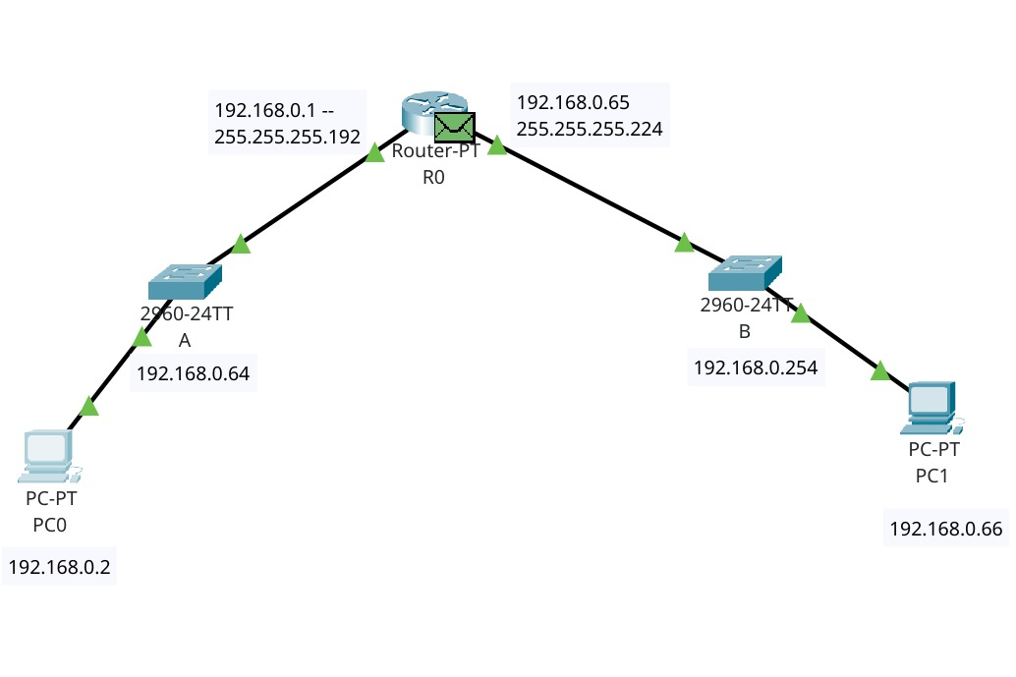

ARP REPLY:

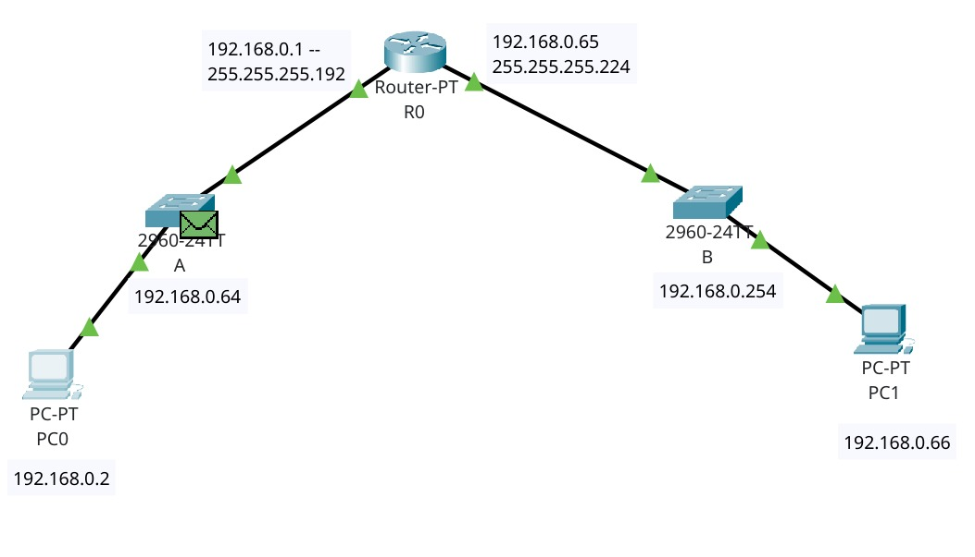

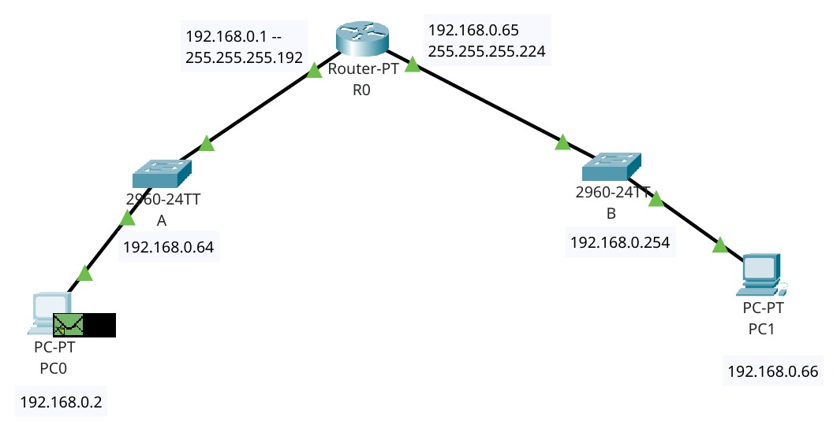

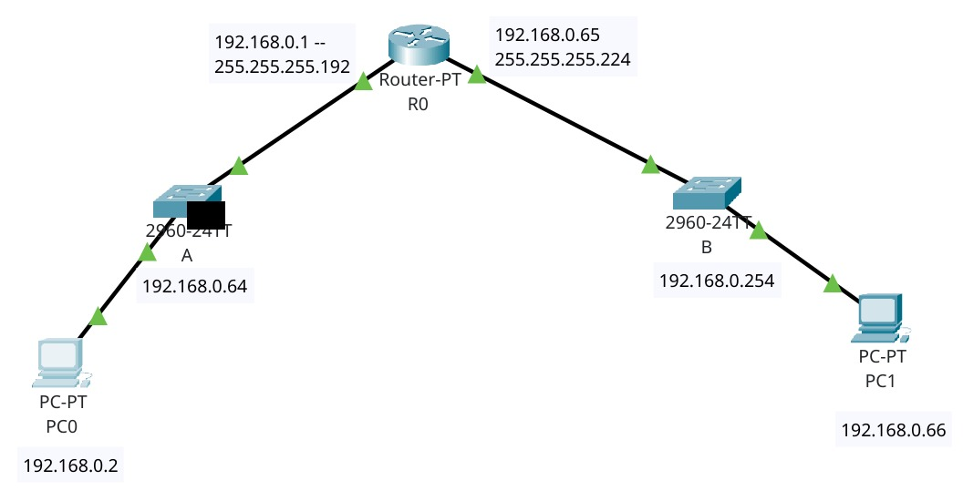

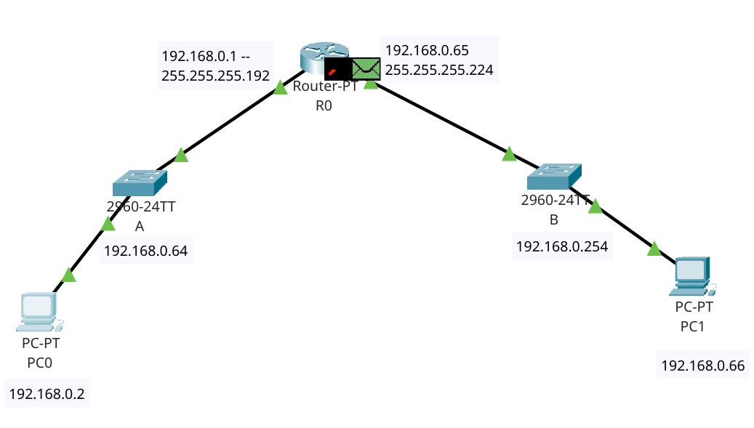

ARP REQUEST:

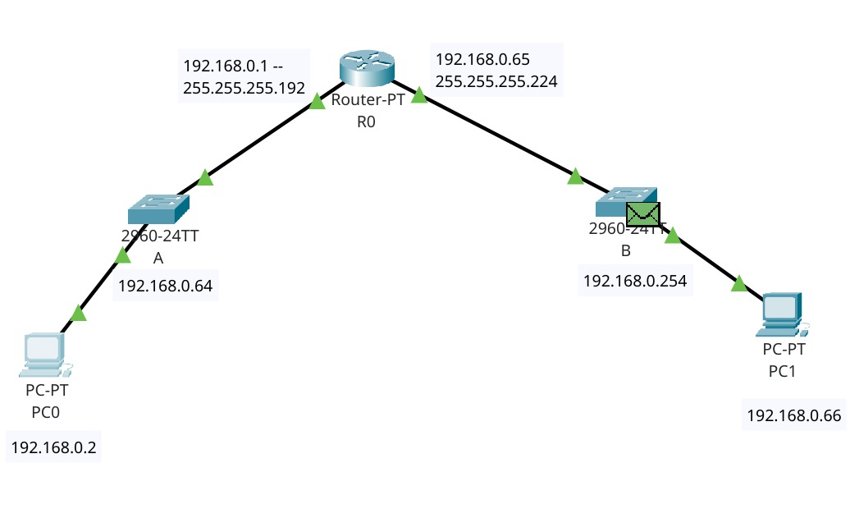

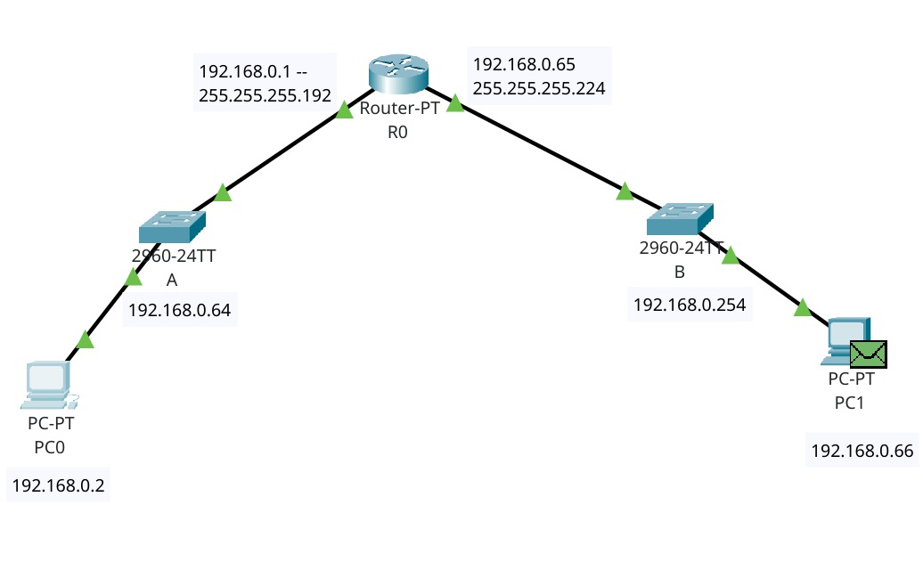

ARP REPLY:



